**The Hardware**

When planning the hardware, we tried to follow the Sense-Think-Act guidelines of Bosch engineering. This concept allows us to build a powerful, safe and transparent hardware design containing all the necessary elements of the ACAS (Animal Collision Avoidance System).

**Sensing**

The key components of the system are the two infra cameras. The main difficulty of detecting animals in the dark forest is obvious: normal cameras working with visible light spectrum are not able to detect the danger, nor is the driver, as animals tend to hide between the trees and plants, making them nearly invisible from greater distances, especially in the dark. Heat cameras detecting the mid-infrared spectrum can easily locate animals, as they are mostly much warmer than their environment.

The optics and detectors of the cameras are elaborated in the Camera section.

The cameras are placed into the top left and right corners of the windscreen. This way, the cameras are kept safe from environmental effects like dust, rain and temperature gradients. The small cameras don’t affect the driver, but the relatively large distance between the cameras allow the system to use distance measuring algorithms more precisely. The cameras are built onto SoC chips, which are put into a black plastic housing which cover the cameras and keep it safe. The SoC chips perform some preprocessing work on the frames captured and compress them to allow data transfer via the MOST interface with 150 Mbps maximal bandwidth.

**Thinking**

Further image processing, classifying and information transfer is done in the dedicated ECU of the ACAS system. Due to the high number of calculations performed, the system requires an own, dedicated ECU to work, which is placed under the whipers at the back of the engine bay. This position can be used for such applications in almost every car, many brands place ECUs here, so this is quite a universal solution.

The components of the ECU perform diverse tasks. The majority of the calculations are done in the GPU. The GPU is optimized for image processing tasks, hence it can perform a high number of calculations in a short period of time.

This produces lots of heat which must be withdrawn from the ECU. The aluminium housing of the ECU is therefore equipped with heat sinking lamelles and a cooling fan dissipating heat from the ECU. The fan is regulated with the cooling control IC. The ECU has to operate without interruption in the temperature range of -30°C to 80°C. More extreme temperatures have very low possibility, the broadening of the temperature range would make the system too expensive.

The processor of the ECU regulates every process, transfers the video input to the GPU and communicates with the further systems of the ACAS via the outputs. A further essential component is the memory, which stores the algorithms and files required for image processing. The main input of the ECU are the MOST interface cables coming from the cameras transferring the video captured by the two infrared cameras. Another input is the vehicle dynamics, containing information about the speed, acceleration, and direction of the car. This is connected to the ECU with CAN-FD cables. This information is necessary to compute the trajectory of the car, hence calculating crash probability with the animal. Outputs from the ECU run via CAN-FD cables as well, as these are only commands which doesn’t require high bandwidth. One of the cables run to the Vehicle Control Unit, transferring commands about braking the vehicle. Two cables go into the cockpit of the car to control the warning signals and the sounds. The aluminium housing of the ECU protects it from environmental effects, dissipates heat and holds the sockets of the inputs and outputs.

All components energy supply is based on the accumulator of the car. The accumulator produces 12/24V DC on its inputs. To save the components from shorts, the energy supply system is equipped with Transient Protection and Reverse Battery Protection. A further EMI filter modul is built into the power supply system to suppress harmful electromagnetic interference. The cameras run with 12V DC, the ECU with 5V DC. These voltages levels are set with DC-DC converters supplying the systems directly with the required voltage. For uninterrupted power, both the cameras and the ECU are equipped with backup capacitors to supply energy in case of a short (<1s) power failure. Capacity values required are around 47mF, the aging of the components also taken into consideration.

**Acting**

The ECU processes the images captured by the infra cameras. If an animal is within the “danger zone”, the field from which the animal can enter the road in a way that it can lead to collisions, a braking command is transferred to the Vehicle Control Unit. This brakes the car to down to 50 km/h. At this pace, the Multi-Purpose Camera built into the middle of the windscreen activates and if necessary, carries out an emergency braking. The information about the animals is also transmitted to the cockpit, where hazardous movements of animals produce warning light and sound signals to warn the driver from the hazard.

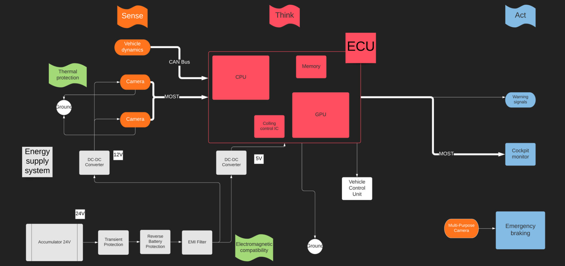The exact form of driver alerting depends on the possibilities in the car. If the car is equipped with Head-Up-Display, the danger signal appears on the windscreen, asking the driver to drive slower and more attentive. (Braking is only carried out if the animal is possibly going to crash into the car, but the simple presence of animals next to the road in dangerous positions also requires slowing down. The exact driver-alerting mechanism is elaborated in the Decision section.) Many cars nowadays are equipped with ambient lighting. If so, the ambient lights can switch on and start blinking at the side of the car where the animal is. The cockpit display/monitor of the car can stream the video captured by the infrared camera to help the driver locate the animal in the dark forest. Further warning sound signals can alert the driver.